**Evidence for Project Unit**

Hamish Stewart

Cohort E16

Sept. 2017 to Jan. 2018

**P- 1 Github Contributors page**

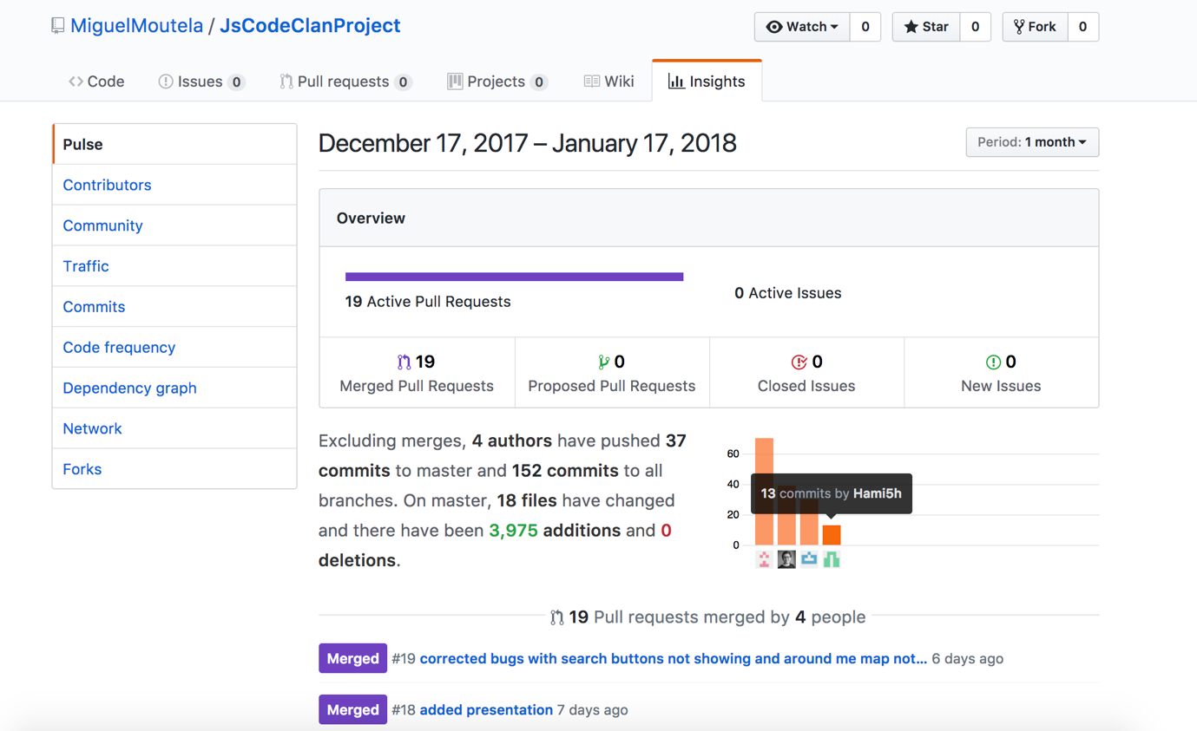

The above is a screenshot of my group project contributors page from Git Hub.

**P- 2 Project Brief**

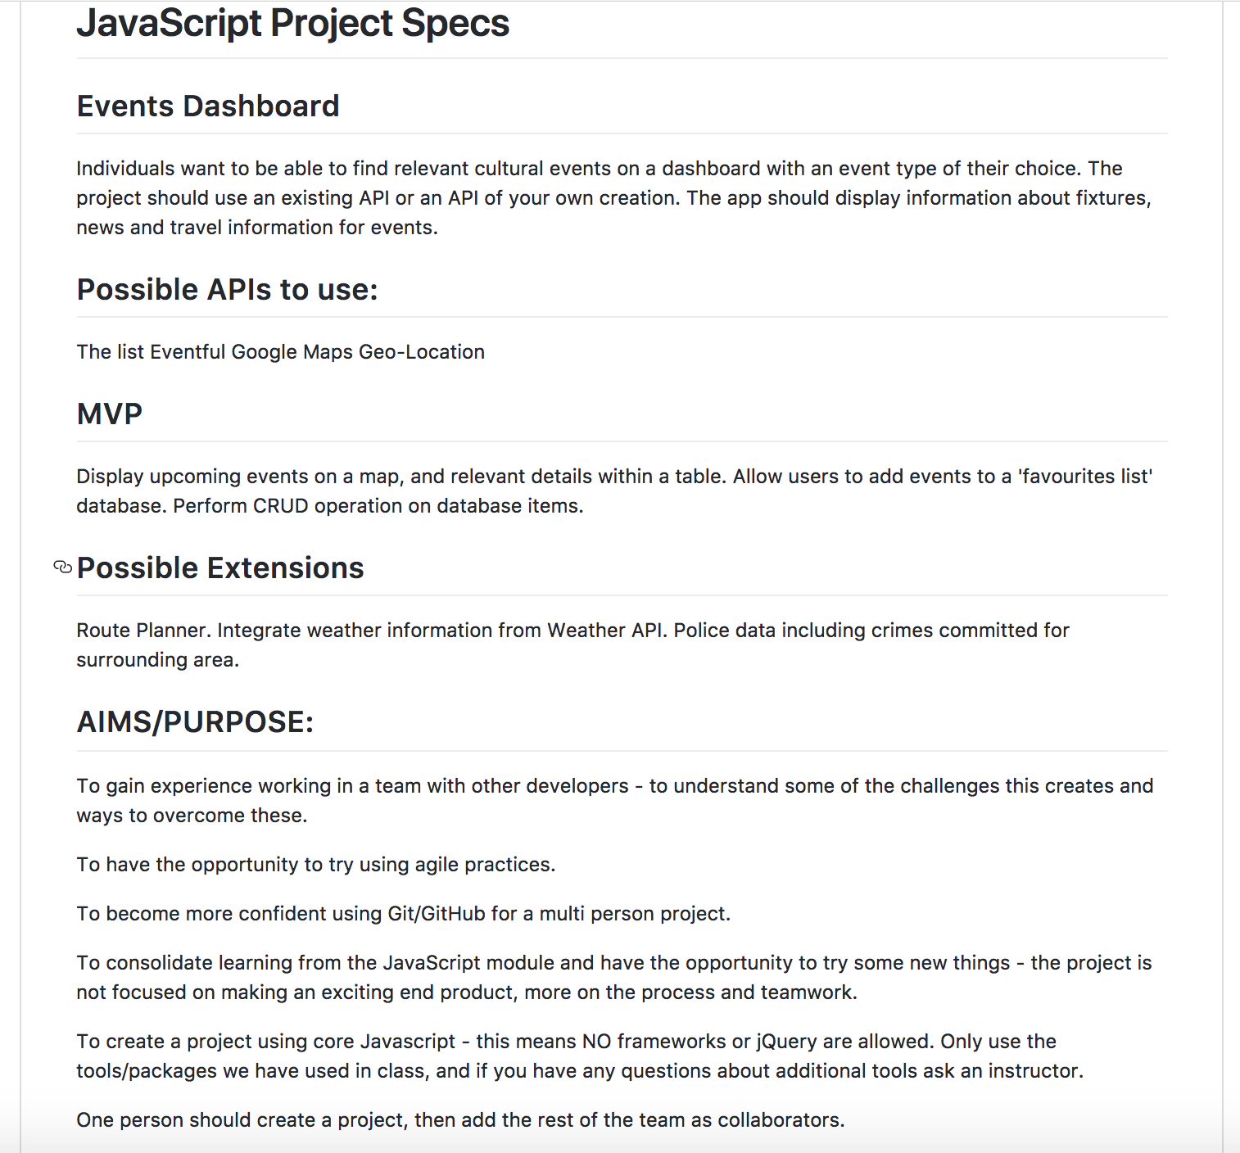

**P-3 Use of Trello**

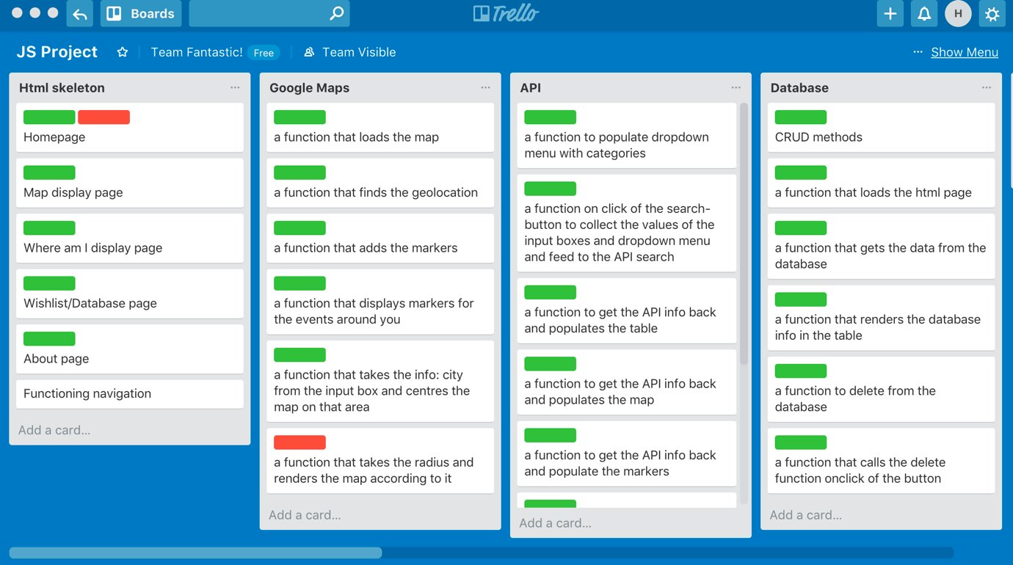

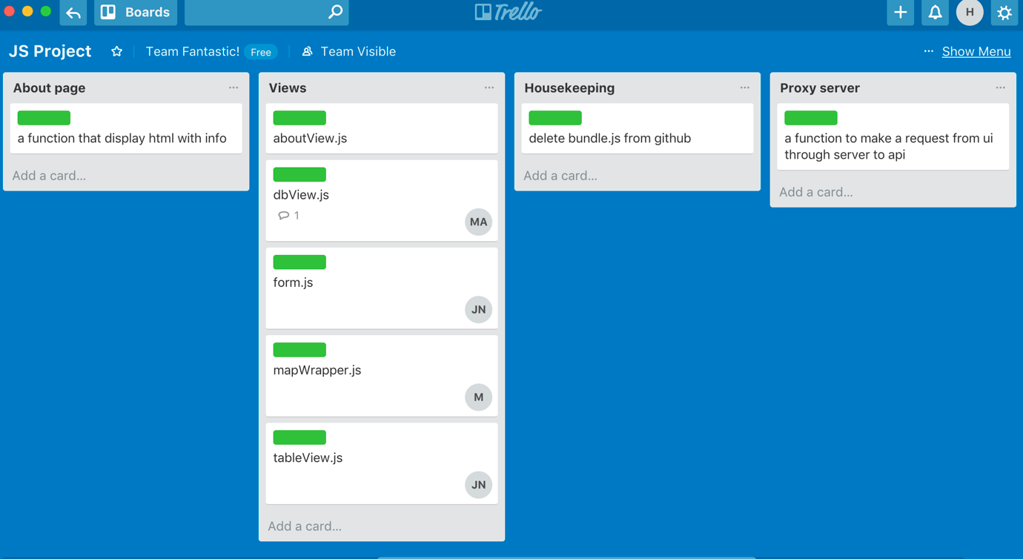

**P-4 Acceptance Criteria**

|  |  |  |
| --- | --- | --- |
| **Acceptance Criteria** | **Expected Result** | **Outcome** |
| A user should be able to select a City. | Selecting the ‘City’ should redirect the user to the City input page. | Test passed |
| A user should be able to input the City name in the input box and the event type, to return a list of results based on their selection criteria. | Markers should drop0 on the map for each event and the table should display all events. | Test passed. |
| A user should be able to save a selected event on the table to the database. | A message should display stating the event has been added to the database | Test passed. |
| A user should be able to view all events saved in the database and delete them if required. | A table should show all the saved events and individual events can be deleted. | Test passed. |

**P-5 User sitemap**

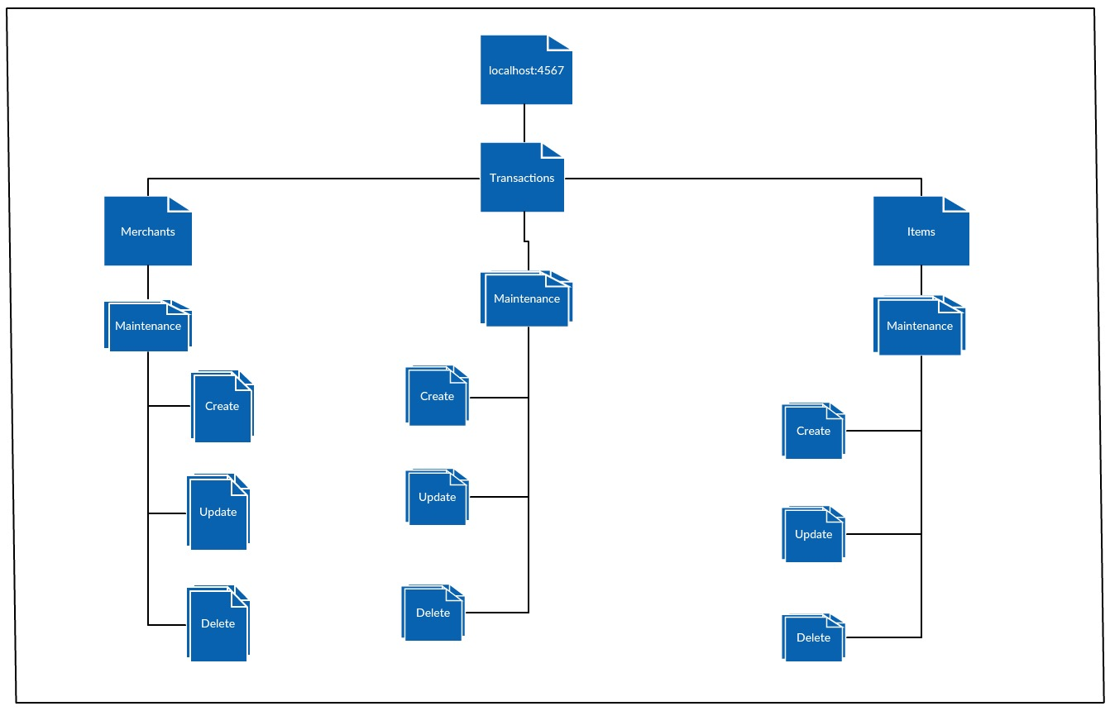

**P-6 Wireframes designs**

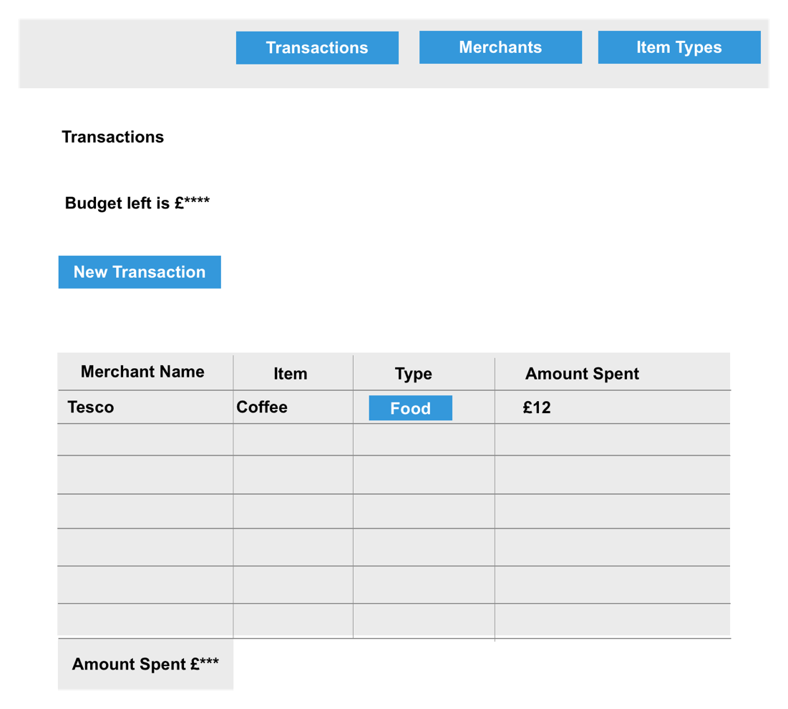



**P-7 System interactions diagrams**

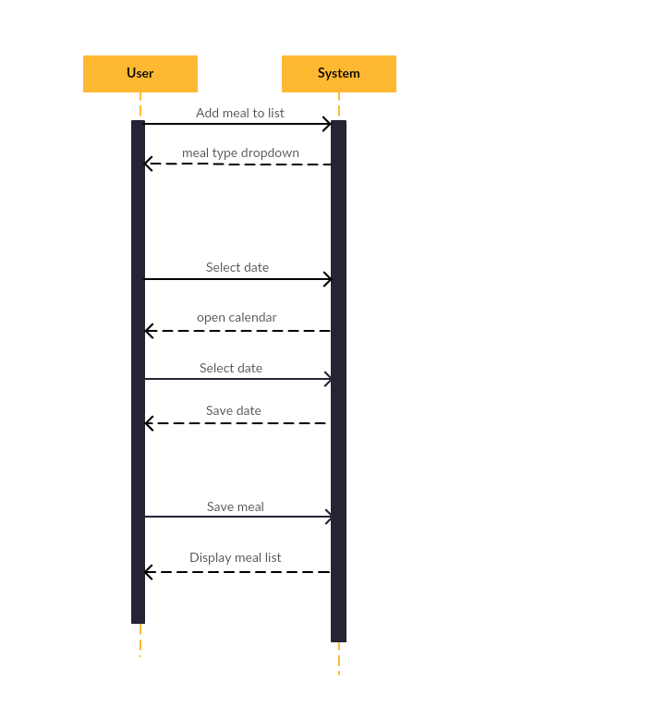

**The above is a sequence diagram for my Food Tracker project.**

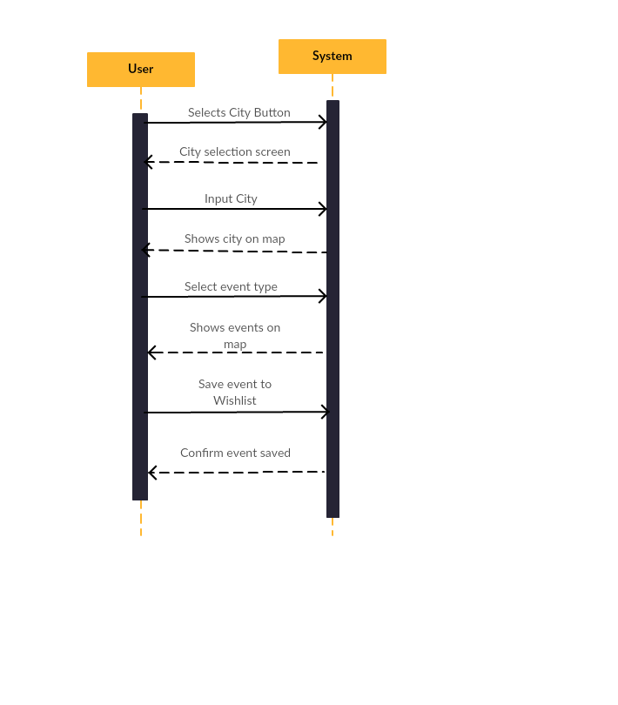

**The above is a sequence diagram for the event list group project**

**P-8 Two Object Diagrams**

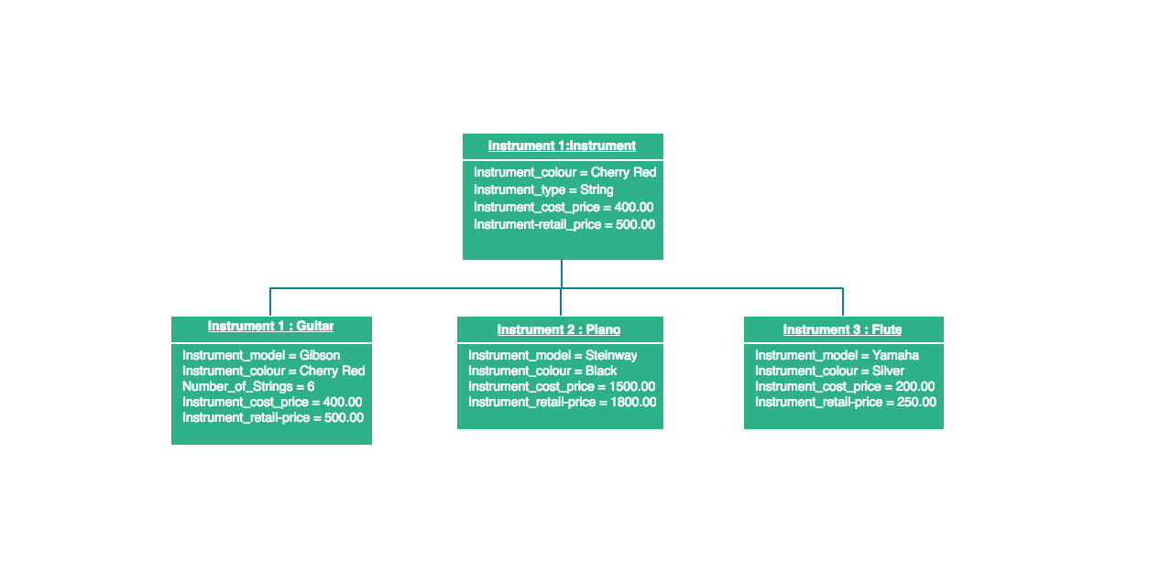

**The above is an object diagram for an instrument class.**

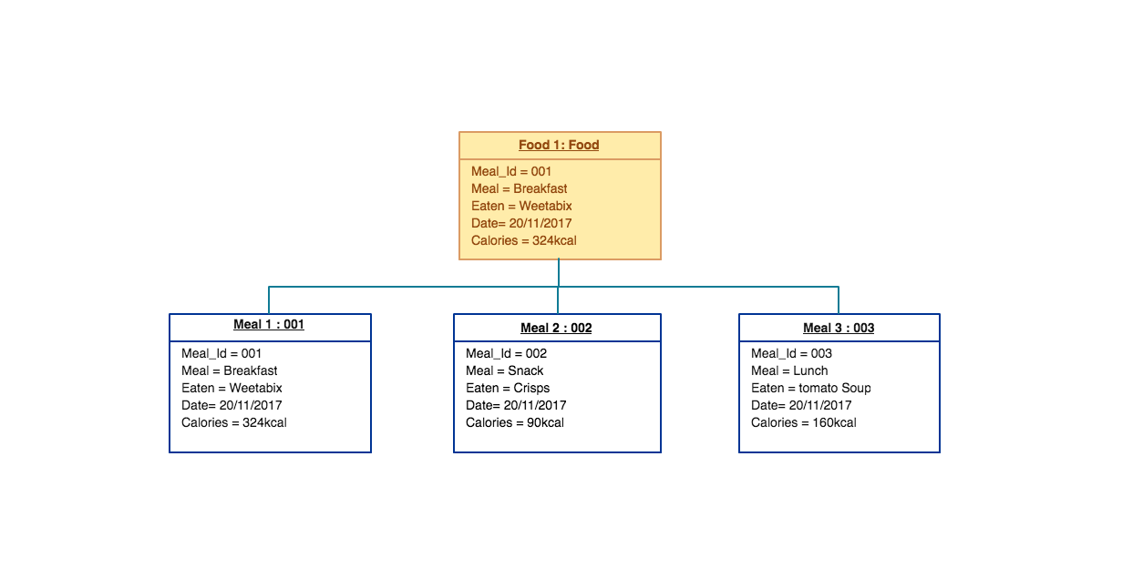

**The above is an object diagram based on my food tracker project.**

**P- 9 Algorithms**

**A – The above algorithm is used to determine whether or not a given year is a leap year. To determine if it is a leap year it firstly checks if the input value is divisible by 4 and if true checks that is not divisible by 100. If both these conditions are met then it is a leap year. In addition, there is a leap year every 400 years, so for example 2000 which is evenly divisible by 400, is a leap year, whereas 1900 is not. The second part of the algorithm checks for this.**

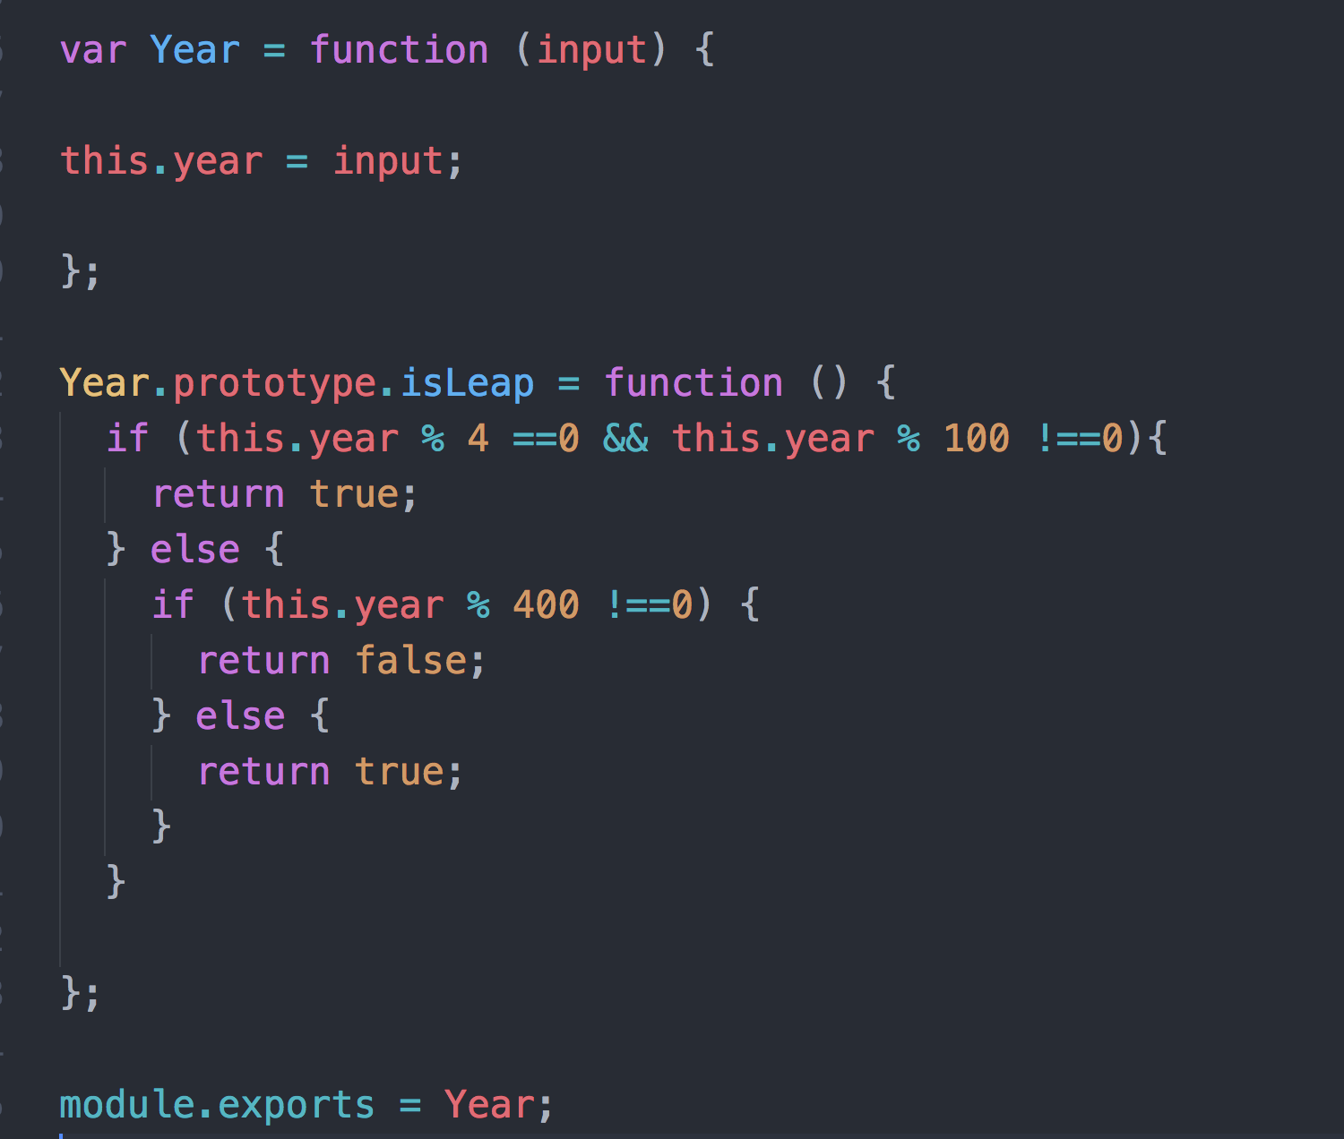

**B- The following algorithm is used to transcribe a DNA strand to an RNA strand.**

**Both DNA and RNA strands are a sequence of nucleotides.**

**The four nucleotides found in DNA are adenine (A), cytosine (C),**

**guanine (G) and thymine (T).**

**The four nucleotides found in RNA are adenine (A), cytosine (C),**

**guanine (G) and uracil (U).**

**Given a DNA strand, its transcribed RNA strand is formed by replacing**

**each nucleotide with its complement:**

**`G` -> `C`**

**`C` -> `G`**

**`T` -> `A`**

**`A` -> `U`**

**The below algorithm checks each character within a given DNA strand and transcribes it to produce and return the desired RNA strand. It will also check for invalid characters.**

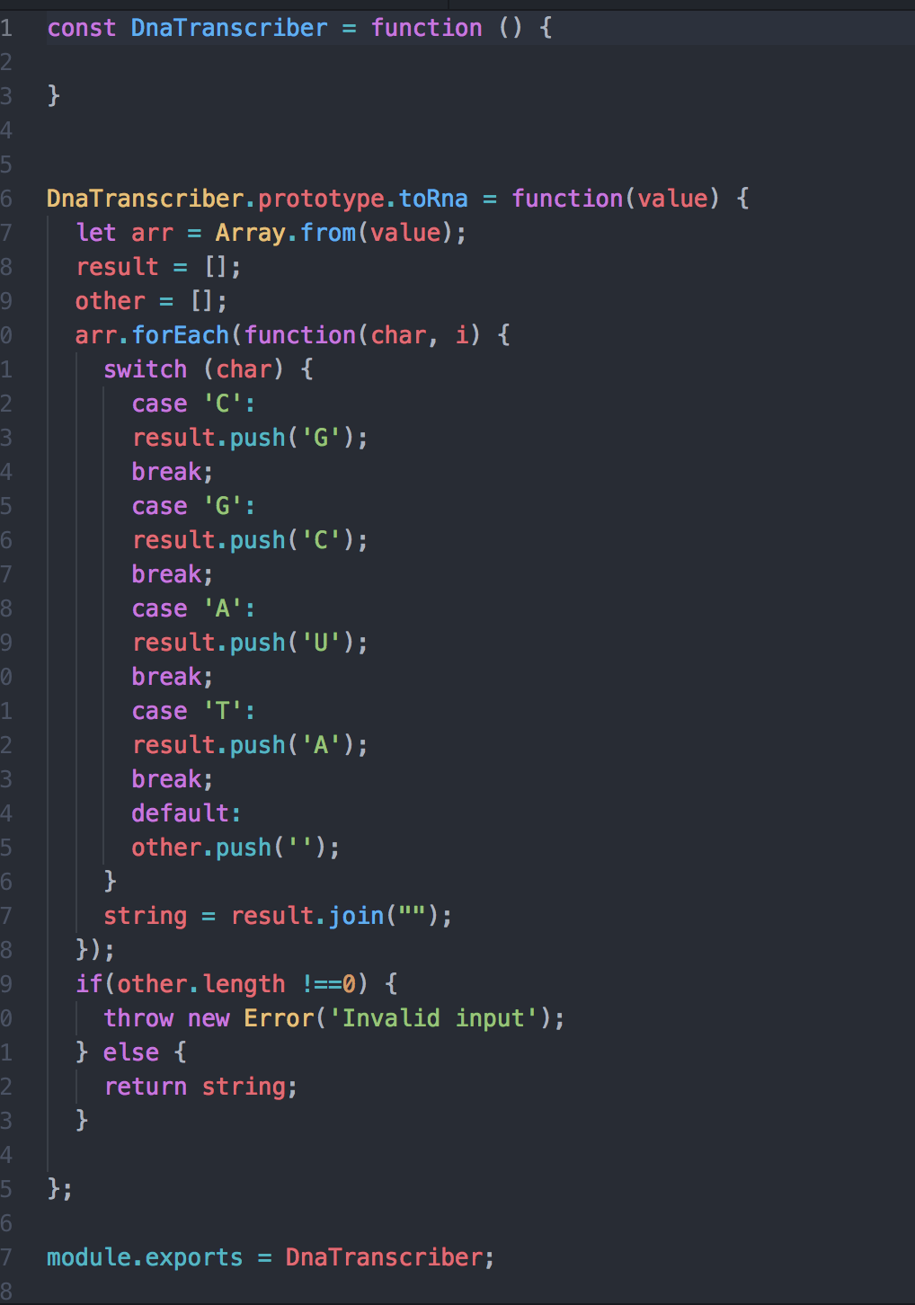

**P - 10 Example of Pseudocode**

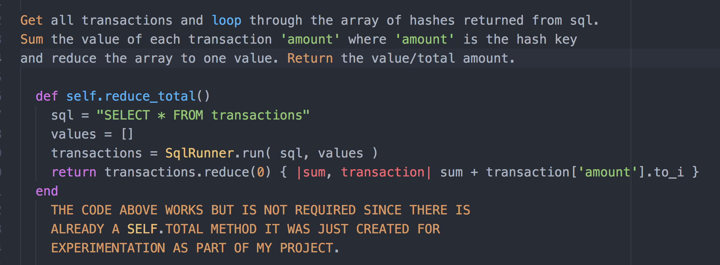

**P - 11 Github link to one of your projects**

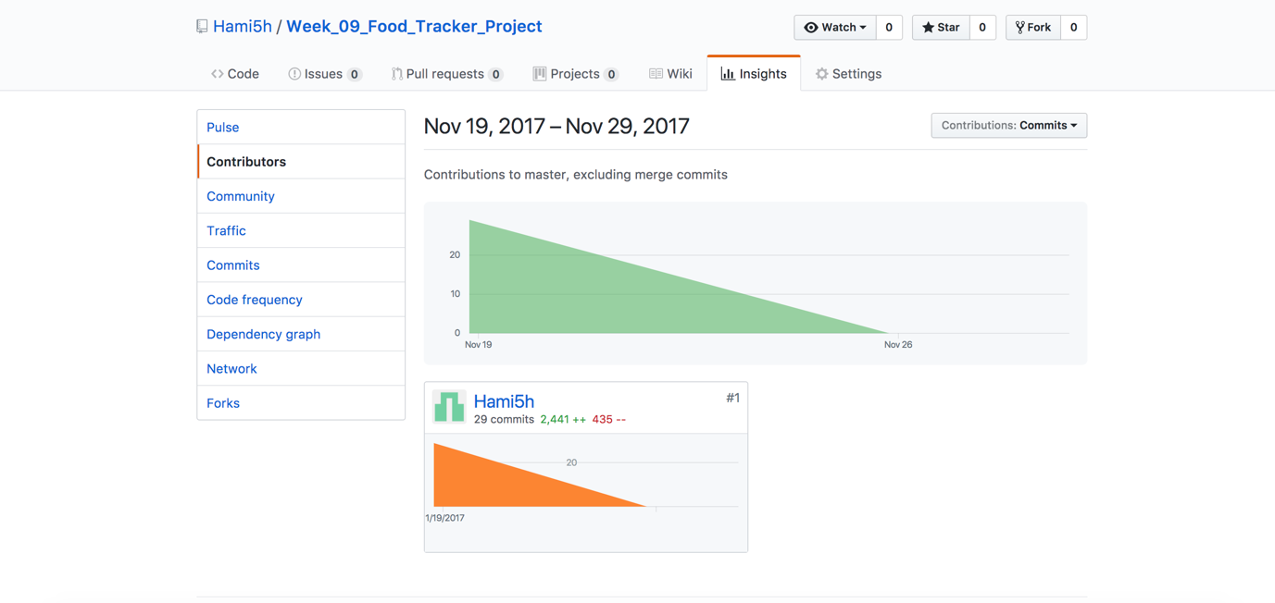

**P - 12 Screenshot of your planning and the different stages of development to show changes.**

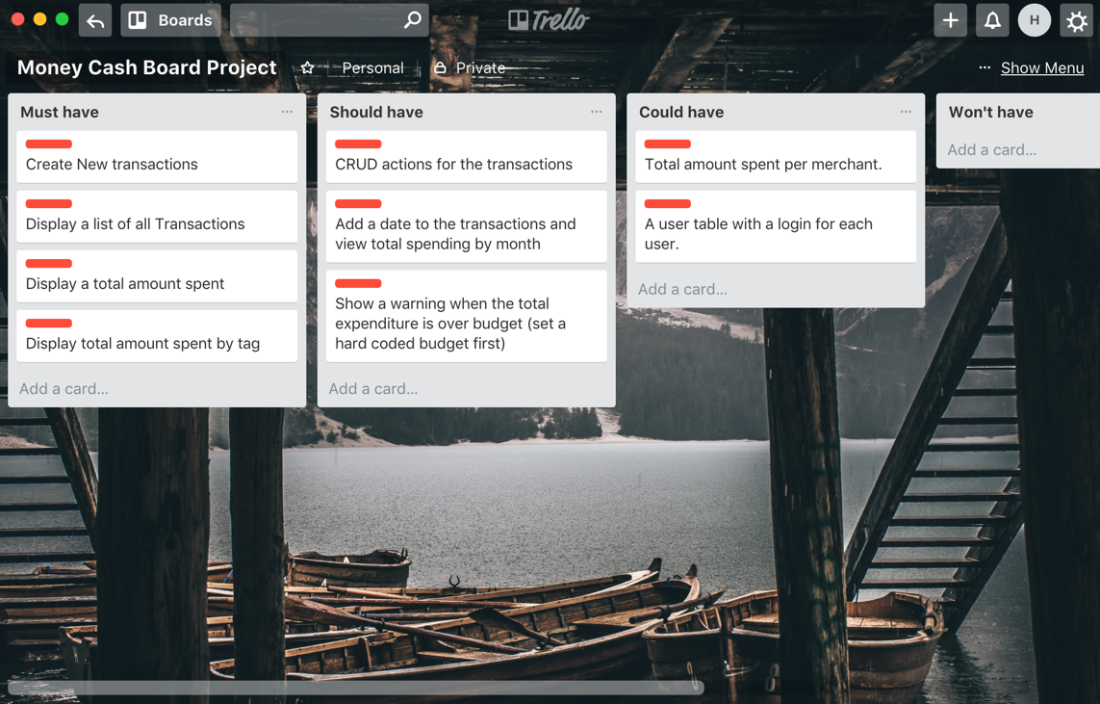

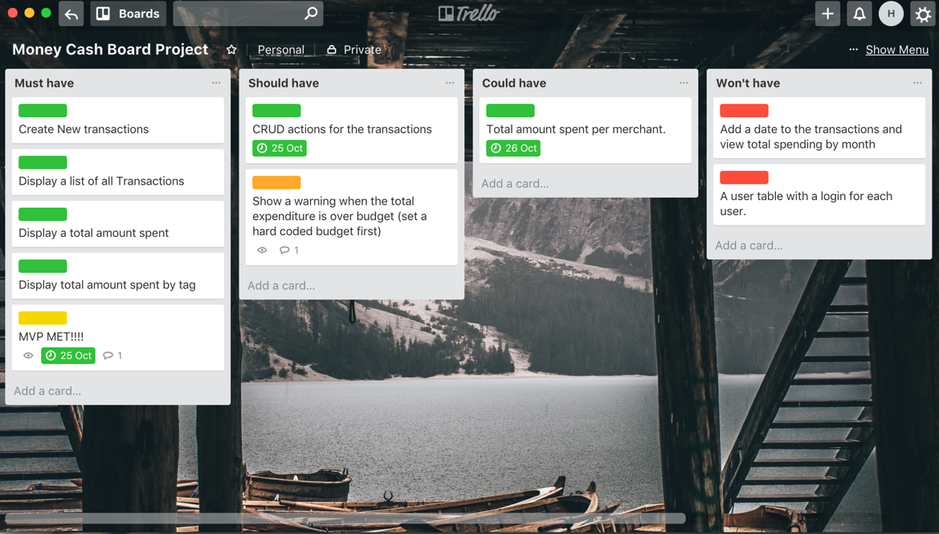

**P - 13 User input**

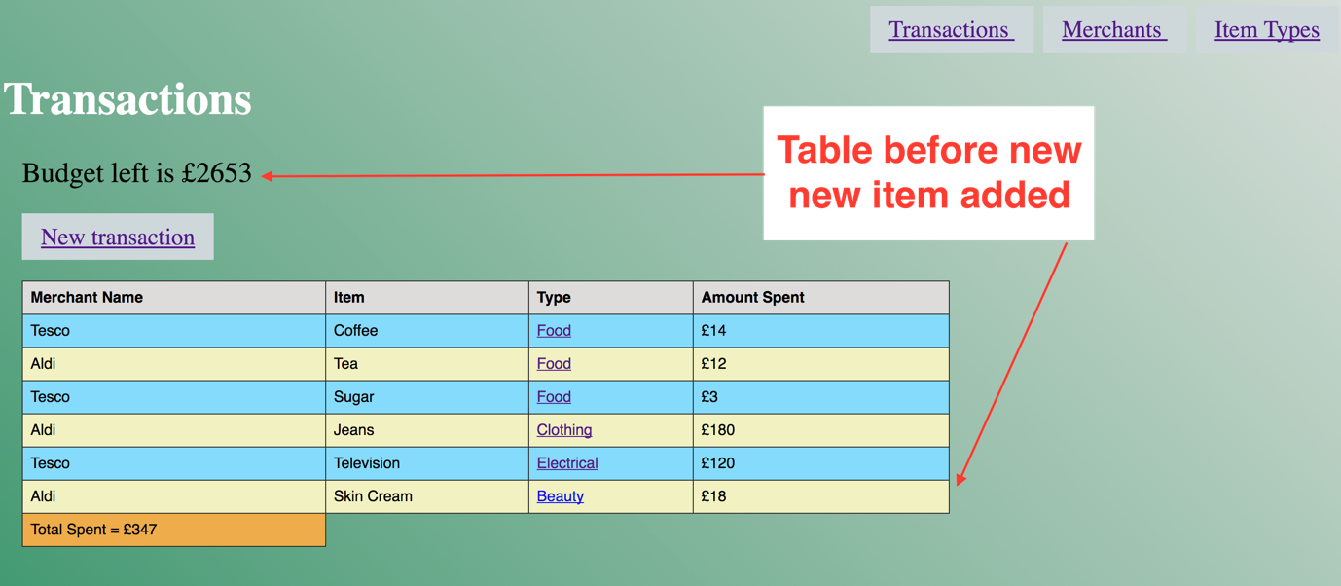

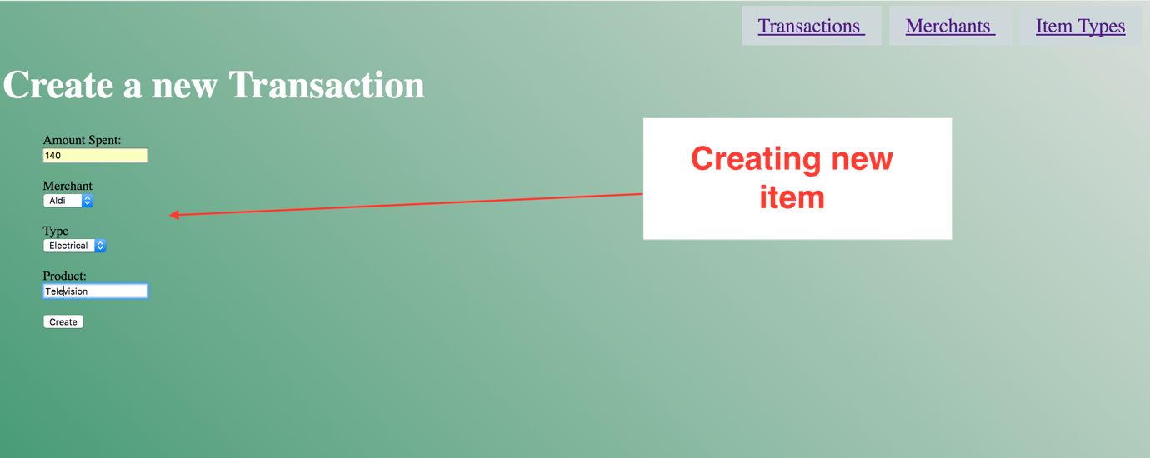

**P - 14 Interaction with data persistence**

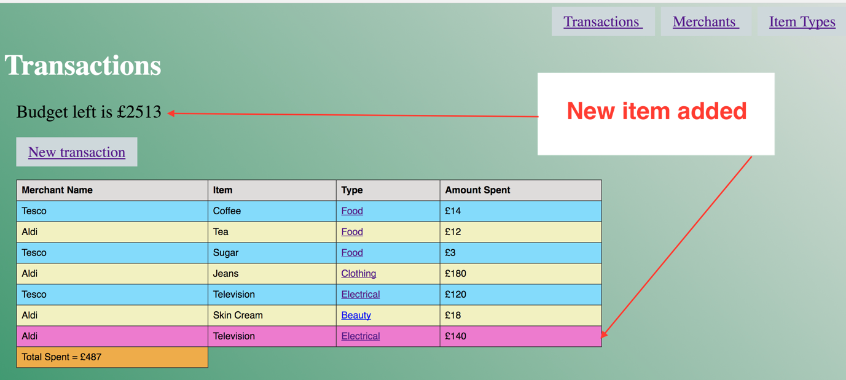

**P - 15 User output result**

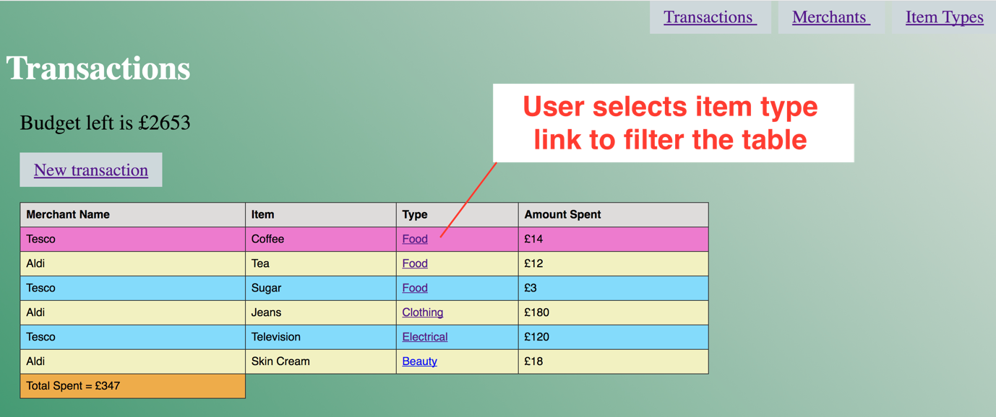

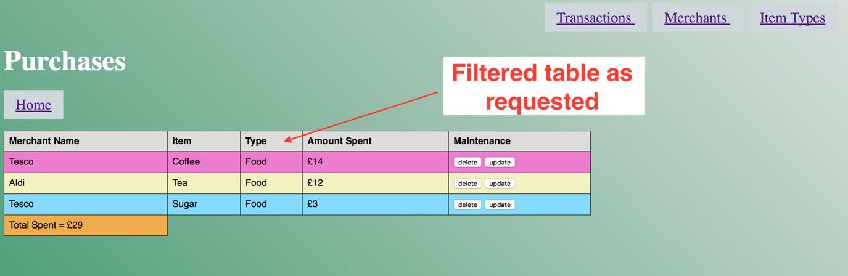

**P - 16 Show an API being used within your program.**

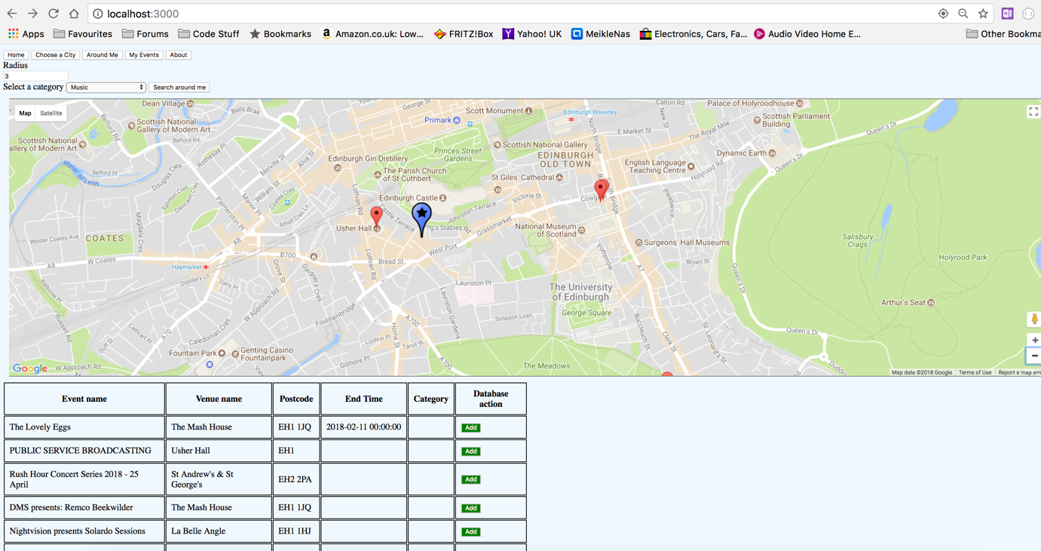

**The above shows the use of the Google maps API showing events nearby from the Eventful API**

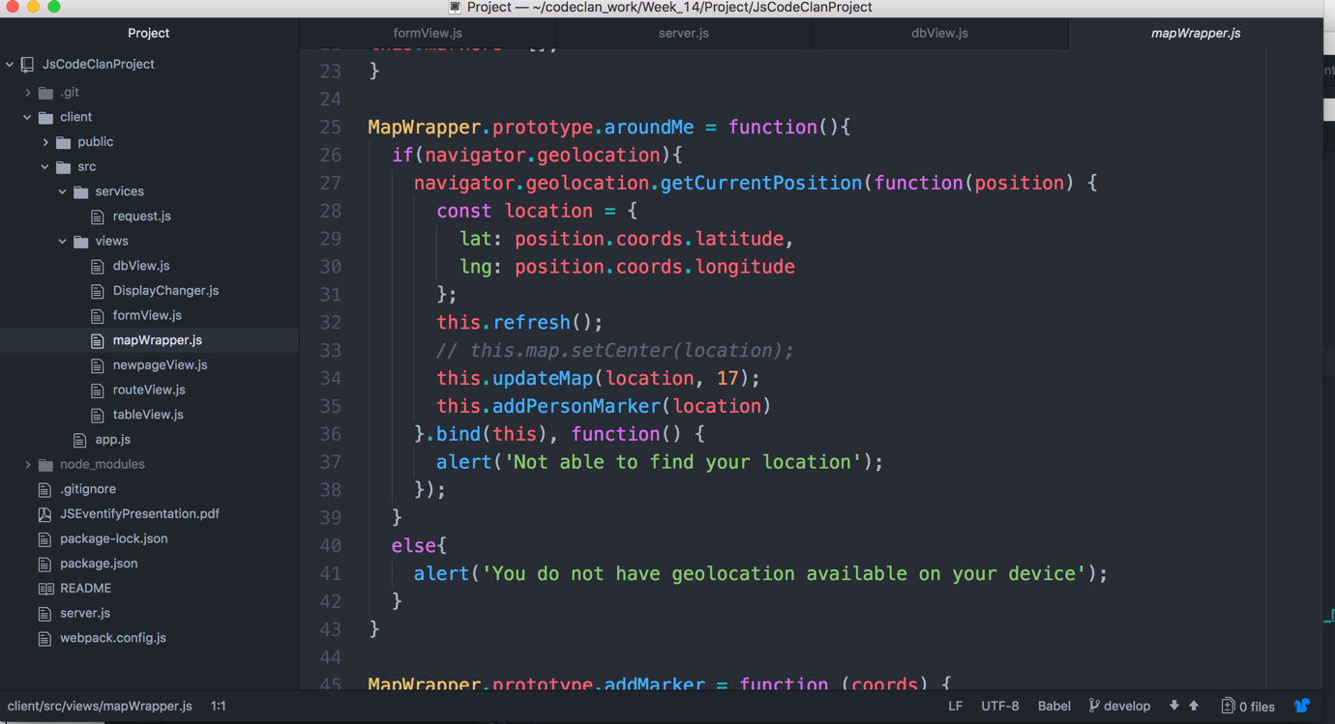

**The above shows the aroundme function in the program which is using geolocation.**

**P – 17 Produce a bug tracking report.**

|  |  |  |  |
| --- | --- | --- | --- |
| **Test** | **Pass/Fail** | **What is the solution** | **Pass/Fail** |
| Map will show current location | fail | Implement geo-location | pass |
| Map should drop marker for each event | fail | Include addMarker function to google mapWrapper | pass |
| User can search for event by city | fail | Use eventful api and provide dropdown for events | pass |
| Event search results should be displayed in a table | fail | A new table should be created below the map | pass |

**P -18 Testing your program**

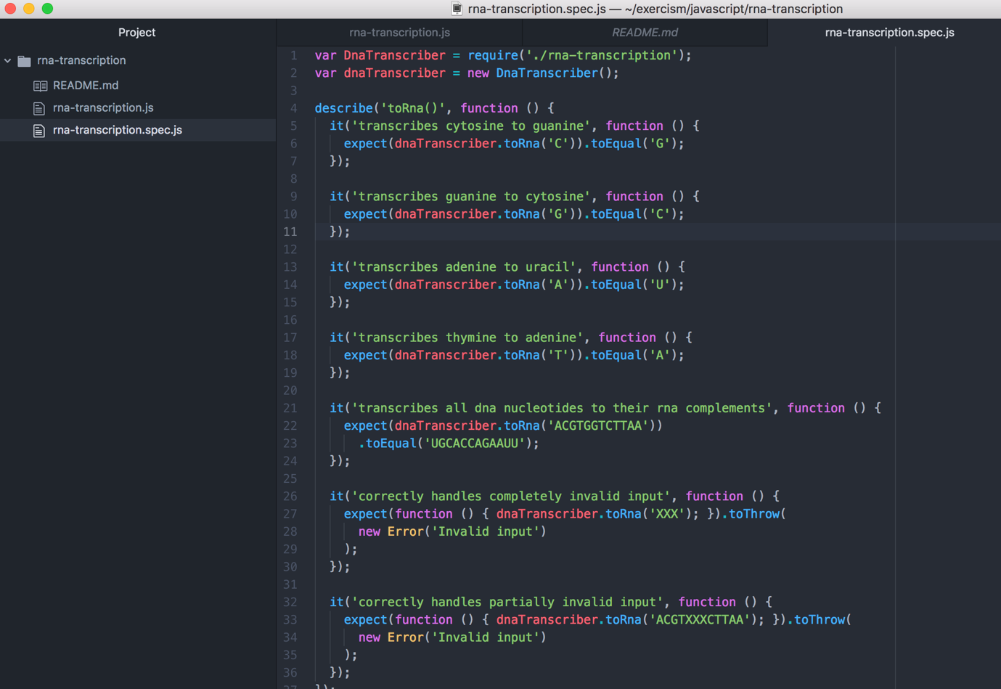

**The above is the test code used.**

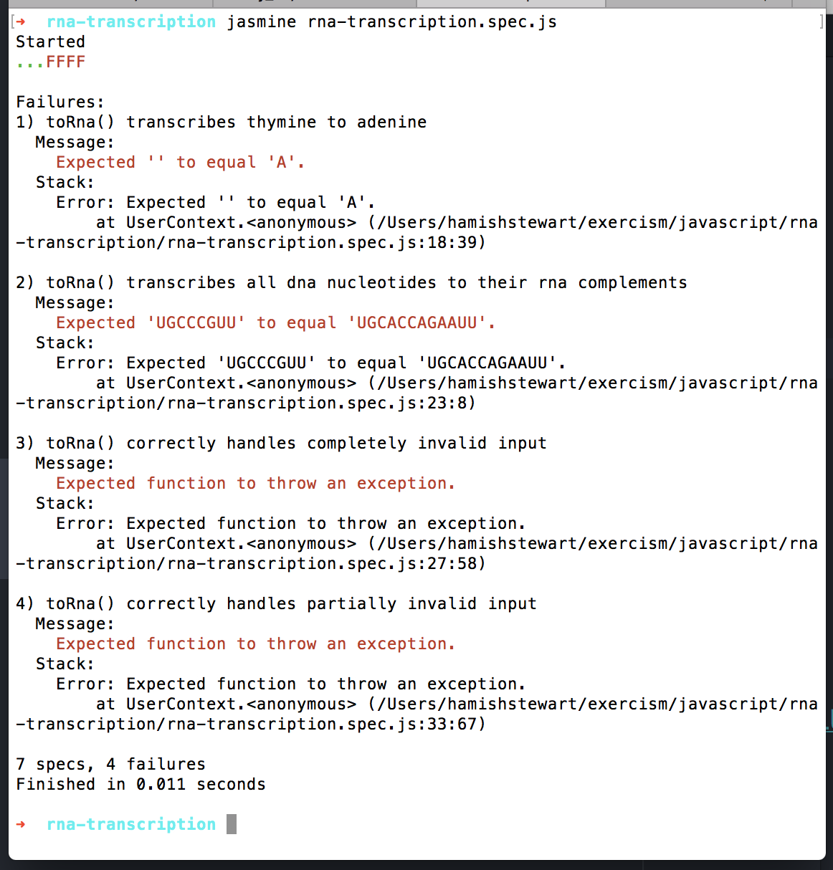

**The above shows the first 3 tests passing and the final 4 failing.**

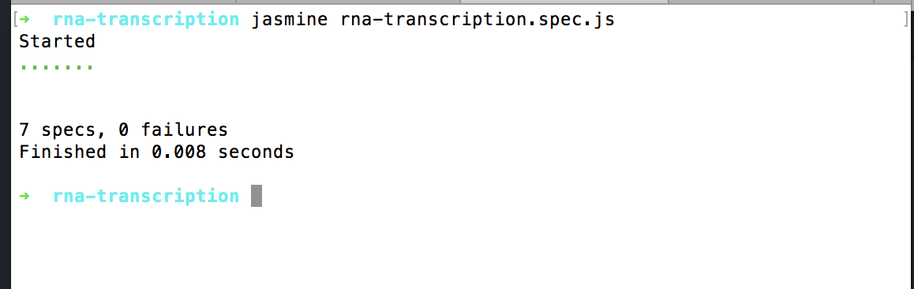

**The above shows the tests passing once the errors have been fixed.**